Helen Frankenthaler Foundation

***PITTURA/PANORAMA***

***Paintings by Helen Frankenthaler, 1952–1992***

**Museo di Palazzo Grimani, Venice May 7–November 17, 2019**

*Helen Frankenthaler (1928–2011), whose career spanned six decades, has long been recognized as one of the great American artists of the twentieth century. She was eminent among the second generation of postwar American abstract painters and is widely credited for playing a pivotal role in the transition from Abstract Expressionism to Color Field painting. Through her invention of the soak-stain technique, she expanded the possibilities of abstract painting, while at times referencing figuration and landscape in unique ways. She produced a body of work whose impact on contemporary art has been profound and continues to grow.*

*For Immediate Release—New York, NY, & Venice, IT—April 2019*

The **Helen Frankenthaler Foundation** and **Venetian Heritage** are pleased to announce an exhibition of Helen Frankenthaler’s paintings drawn from the Foundation’s collection, which will be the first presentation of her work in Venice since its appearance in 1966 at the American Pavilion of the 33rd Venice Biennale. The exhibition will feature fourteen paintings covering a forty-year span of the artist’s career. It will focus on the relationship in Frankenthaler’s development of the *pittura* and the *panorama*: the interplay of works like easel paintings, although made on the floor, and large, horizontal paintings that open onto shallow but expansive spaces, in the way that panoramas do.

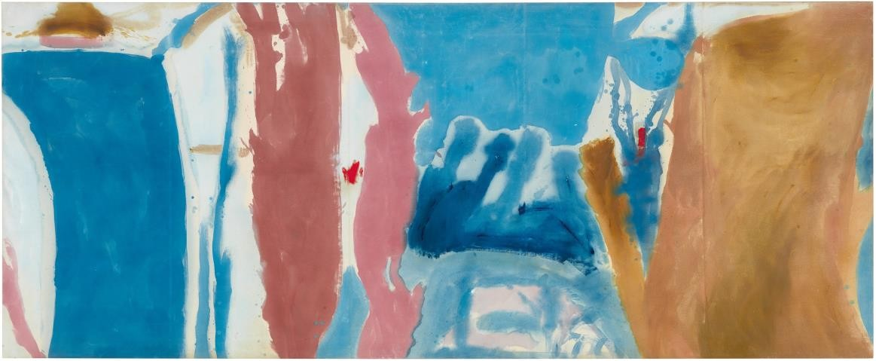

*Open Wall*, 1953

The exhibition was organized by the **Helen Frankenthaler Foundation** and **Venetian Heritage**, in association with **Gagosian**. It will be presented at the **Palazzo Grimani** in Santa Maria Formosa, one of the most important cultural centers in Venice during the 16th century and home to a family famous for both its collections and its patronage of the arts. Helen Frankenthaler was influenced in her use of color by the great Venetian artists of the 1500s, making the venue particularly appropriate for this exhibition.

# The Exhibition

The exhibition was curated by John Elderfield, Chief Curator Emeritus of Painting and Sculpture, The Museum of Modern Art, New York; Consulting Curator, Princeton University Art Museum; and a Senior Curator, Gagosian. It includes panoramic works ranging from *Open Wall* (1953), a painting that anticipated the work of the Color Field school of the 1960s, to Frankenthaler’s richly atmospheric canvases of the early 1990s. The works will be installed in a broadly but not strictly chronological sequence, revealing connections between works of different periods, and a development of both continuity and continuing change. They comprise four major groupings:

**1950s:** Frankenthaler’s first experience of large, horizontal contemporary paintings was in 1950 when, as a twenty-one-year-old artist not long out of college, she saw abstract compositions by Jackson Pollock made with looping skeins of poured paint. In the earliest canvas in the exhibition, *Window Shade No. 2* (1952), she tried something similar on a smaller scale; then applied the lesson to works alluding to landscape, as with *10/29/52*. And, when Frankenthaler made a big horizontal picture, such as *Open Wall*, it was with broad areas as well as lines of paint: Its title shows that she was conscious of the early 1950s debate among New York painters and critics, as to whether a painting should be like a window or a wall. She wanted both, a wall that was open.

**1960s:** For Frankenthaler, a painting was an expanse of flat surface that created the illusion of spatial depth. In the 1960s, the former tended to dominate in her work. In *Italian Beach* (1960), painted at Alassio, abbreviations for a hilltop, a band of foliage, and an expanse of sand bridge the space from a pool of sea-blue to the right edge of the canvas. *Pink Bird Figure* (1961) expands the flat image of a bird above a flight path drawn horizontally across the painting. But with *Riverhead* (1963), she re-engaged the painterliness of her 1950s canvases in a more sumptuous manner.

**1970s–1980s:** The graphic treatment of *New Paths* (1973) may suggest that the artist has, in fact, revived the old path of her 1960s canvases. But it is a new one, combining flat, schematic marking with an inventive manner of opening pictorial space: She graded the narrow ribbons that span the light horizontal channel so that they appear to recede as they diminish in size. By the early 1980s, though, Frankenthaler had first amplified the painterly approach of *Riverhead*—as in *For E.M.* (1981)—and then again readjusted her pictorial vocabulary: She laid down monochromatic fields of atmospheric color and superimposed a scatter of dabs, dots, and dashes of more tangible pigment, as with *Brother Angel* (1983), or floating islands of color and calligraphic lines, with *Madrid* (1984).

**1990s:** Frankenthaler’s work of the 1990s, being less well-known, is represented here by four major canvases from early in that decade. In these, she looks back again to the painterliness of *Riverhead* thirty years earlier, filling out these new canvases in an even more dramatic manner. As a younger artist she had said, “My pictures are full of climates, abstract climates, and not nature per se.” The titles of her canvases of the 1990s evoke extreme climatic conditions—*Maelstrom* (1992)— or places in which they occur—*Snow Basin* (1990)—or their beginning to occur—*Overture* (1992)— or their measurement—*Barometer* (1992). And Frankenthaler’s spreading and layering of stained pigment creates a richly atmospheric evocation of water and sky that ultimately looks back to Venetian painting of the sixteenth century—doing so in a highly personal manner that also points ahead to the work of the many artists who take inspiration from her today.

# Complementary Exhibition in Rome

This exhibition is complemented by *Helen Frankenthaler. Sea Change: A Decade of Paintings, 1974–1983*, on view at Gagosian’s Rome gallery through July 19, 2019.

# The Catalogue

The exhibition will be accompanied by a fully illustrated catalogue, published by Gagosian, with a foreword by Elizabeth Smith, Executive Director, Helen Frankenthaler Foundation, and Toto Bergamo Rossi, Director, Fondazione Venetian Heritage Onlus; a preface by Mr. Elderfield; and a comprehensive essay by Pepe Karmel, Associate Professor of Art History, New York University.

# The Venue

Palazzo Grimani—a rare example of a Venetian palace that blends local architectural elements with Tosco-Roman decorative details—owes its appearance to the interventions carried out by Vittore Grimani and his brother Giovanni Grimani, the Patriarch of Aquileia, during the sixteenth century. Giovanni wanted the Tribuna, an actual “chamber of antiquities,” in order to exhibit the most valuable Greek and Roman statues in his collection. On his death, he donated the sculptures to the Serenissima Repubblica di Venezia, as a result of which his collection left its original home in 1596. Now, 430 years after the artworks left the Palazzo Grimani, they will be reinstalled inside the family palace at Santa Maria Formosa. Curated by Daniele Ferrara, Director of Polo Museale del Veneto, and Toto Bergamo Rossi, Director of Venetian Heritage, the display will be inaugurated in May 2019, during the preview of the Venice Art Biennale, and will remain on view until 2021. The project is produced by Civita Tre Venezie and is made possible thanks to the support of Venetian Heritage, Maison Hermés, the Helen Frankenthaler Foundation, and Gagosian.

# About Venetian Heritage Foundation

Venetian Heritage, an international nonprofit organization with offices in Venice and New York, supports cultural projects through conservation, exhibitions, publications, conferences, academic study, and research. It aims to increase awareness of the immense legacy of Venetian art in Italy and in those areas that were once part of the Republic of Venice. For additional information: [www.venetianheritage.eu.](http://www.venetianheritage.eu/)

# About Helen Frankenthaler Foundation

The New York-based Helen Frankenthaler Foundation, established and endowed by the artist during her lifetime, became active in 2013, on the closing of Frankenthaler’s estate. The Foundation is dedicated to promoting greater public interest in and understanding of the visual arts. It supports the artist’s legacy through a variety of initiatives, including exhibitions, loans of artworks, research and publications, conservation, grants, educational programs for the public and the scholarly community, and the publishing of a catalogue raisonné. As the principal beneficiary of Frankenthaler’s estate, its holdings include an extensive selection of her work in a variety of mediums, her collection of works by other artists, and original papers and materials pertaining to her life and work. For additional information: [www.frankenthalerfoundation.org.](http://www.frankenthalerfoundation.org/)

**For additional press information:**

* * *

In Venice, Giovanni Sgrignuoli, [giovanni@gmspress.com,](mailto:giovanni@gmspress.com) +39 328 9686390

In New York City, Jeanne Collins, [press@frankenthalerfoundation.org,](mailto:press@frankenthalerfoundation.org) +1 212 268 4937

**Visitor information:**

***PITTURA/PANORAMA. Paintings by Helen Frankenthaler, 1952–1992***

May 7–November 17, 2019

Museo di Palazzo Grimani, Castello, 4858A, Venice Open Tuesday–Sunday, 10am–7pm

Vaporetto stops: Rialto; San Zaccaria; Ospedale

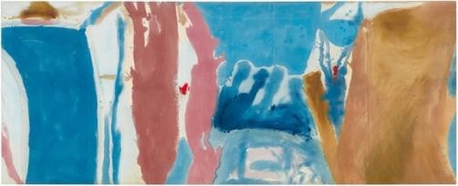

*Open Wall*, 1953, oil on unsized, unprimed canvas, 53 3/4 x 131 inches (136.5 x 332.7 cm)

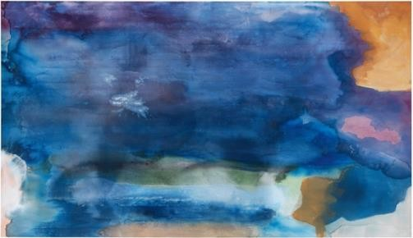

*Riverhead*, 1963, acrylic on canvas,

82 1/4 x 143 inches (208.9 x 363.2 cm)

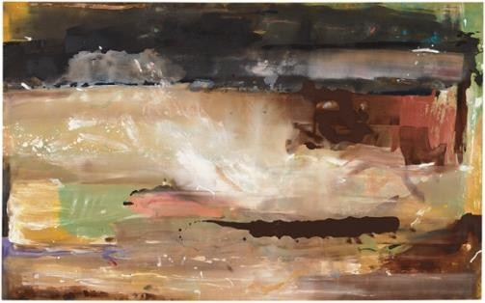

*For E.M.*, 1981, acrylic on canvas,

71 1/4 x 115 1/4 inches (181 x 292.7 cm)

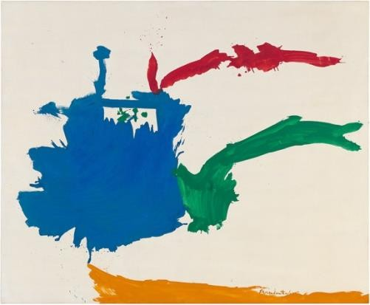*Italian Beach*, 1960, oil on sized, primed linen, 67 1/8 x 82 1/4 inches (170.5 x 208.9 cm)

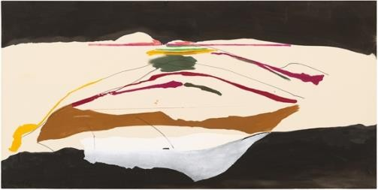

*New Paths*, 1973, acrylic on canvas,

54 3/4 x 109 inches (139.1 x 276.9 cm)

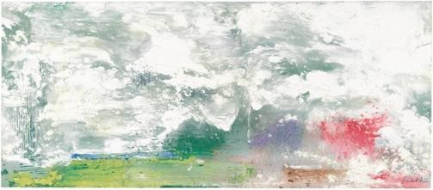

*Maelstrom*, 1992, acrylic on canvas,

46 1/2 x 107 7/16 inches (118.1 x 272.9 cm)

All artwork by Helen Frankenthaler © 2019 Helen Frankenthaler Foundation, Inc. / Artists Rights Society (ARS), New York. Photographs by Rob McKeever, courtesy Gagosian

**For additional information or press images:**

In Venice, Giovanni Sgrignuoli, [giovanni@gmspress.com,](mailto:giovanni@gmspress.com) +39 328 9686390 In New York City, [press@frankenthalerfoundation.org](mailto:press@frankenthalerfoundation.org)